This form must be properly completed and
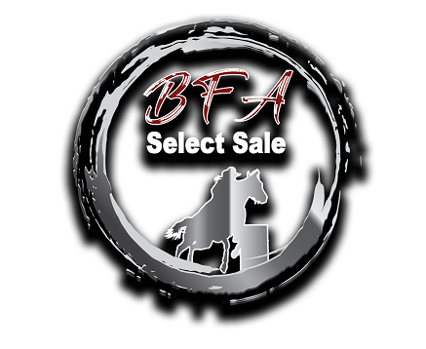
received 24 hours prior to the start of the sale.

BUYER

REGISTRATION
2021 Barrel Futurities of America World Championship
Select Barrel Horse Sale
Sale Date: November 18, 2021 4pm

DATE

GENERAL INFORMATION DL #
NAME  DL COPY ATTACHED
ADDRESS AQHA # CITY, STATE, ZIP
TELEPHONE NUMBERS Home Work Cell
EMPLOYER EMPLOYER ADDRESS CITY, STATE, ZIP EMPLOYER PHONE NO. REFERRED BY

METHOD OF PAYMENT
 CASH  CHECK  CREDIT CARD

Approximate Dollar Amount for Verification $

BANKING INFORMATION

NAME OF BANK ADDRESS CITY, STATE, ZIP CHECKING ACCOUNT NUMBER NUMBER OF YEARS AT THIS BANK BANK OFFICER’S NAME/ TITLE FOR CONTACT PHONE

By signing this account verification, applicant authorizes BFA SELECT SALE to perform a credit investigation.

SIGNATURE OF APPLICANT

Subscribed and sworn before me on this day of 20 NOTARY PUBLIC
COUNTY,

PURCHASE BY CASH

PURCHASE BY CREDIT CARD

CARD HOLDER NAME: _______________________________________________________________________

CARD NUMBER: ____________________________________________________________________________

EXP DATE: __________________ CSV#: _______________________

SIGNATURE OF APPLICANT: __________________________________________________________________

DATE: ____________________________

By signing above, you are authorizing Lazy E Arena, LLC., to collect and deposit payment for any consignments purchased.

For More Information: Lance Powers—405-650-2769 or Braiden Garcia---405-200-6309
Return Form: Lazy E Arena, Attn: Braiden Garcia 9600 Lazy E Dr., Guthrie, OK. 73044
bgarcia@lazye.com 405-282-3004

